BLWE Football Recruiting Content Pack
One file. Football recruiting articles and supporting assets for Be Like Wat3r Exposure LLC (Michigan + Midwest).
Inside this document: (1) all 59 SEO titles/keywords, (2) 10 full publish-ready articles with branded header images, (3) soft CTAs to the free Recruiting Readiness Snapshot. No scholarship promises. Player-first voice.
Brand colors: black #08090D, blue #1D77ED. Site: belikewaterexposure.net

Complete 59-Title Football Recruiting Keyword Map
All titles below are football recruiting / eligibility / camps / film / Midwest exposure topics for BLWE. Articles 1-10 are written in full in this same document with header images. Titles 11-59 are queued for the next writing batches.
1. How to Get Recruited for College Football | kw: how to get recruited football | DONE in this file
2. NCAA Football Eligibility Requirements | kw: ncaa football eligibility | DONE in this file
3. How to Get Football Offers | kw: how to get football offers | DONE in this file
4. Michigan High School Football Recruiting Guide | kw: Michigan high school football recruiting | DONE in this file
5. Football Combine Michigan: Verified Testing | kw: football combine Michigan | DONE in this file
6. Hudl Film for Football Recruiting | kw: Hudl film recruiting | DONE in this file
7. How to Get Noticed by College Football Coaches | kw: how to get noticed by coaches | DONE in this file
8. How to Get D1 Football Offers | kw: how to get d1 football offers | DONE in this file
9. Football Recruiting for Parents | kw: football recruiting parents | DONE in this file
10. Midwest Football Showcase Guide | kw: midwest football showcase | DONE in this file
11. How to Get Recruited for D3 Football | kw: d3 football recruiting
12. How to Get Recruited as a Senior | kw: senior football recruiting
13. NCAA Eligibility Center Signup Steps | kw: eligibility center football
14. NCAA Football Core Courses Explained | kw: ncaa core courses football
15. How to Get Noticed at Football Camps | kw: noticed at football camps
16. How to Get Noticed by D1 Coaches | kw: noticed by d1 coaches
17. How to Get Noticed by Football Recruiters | kw: noticed by recruiters
18. NCAA Redshirt Rules Explained | kw: ncaa redshirt rules
19. Redshirt Rules for Recruits and Parents | kw: redshirt rules college football
20. Virtual Football Recruiting Coaching | kw: virtual recruiting coaching
21. Michigan Football Camps: How to Choose | kw: Michigan football camps
22. Best Midwest Football Combines | kw: Midwest football combines
23. Verified 40-Yard Dash for Recruiting | kw: verified 40 yard dash
24. QB Recruiting Guide for High School | kw: QB recruiting
25. Wide Receiver Recruiting Tips | kw: WR recruiting
26. Running Back Recruiting Guide | kw: RB recruiting
27. Offensive Line Recruiting Measurables | kw: OL recruiting
28. Defensive Line Recruiting Guide | kw: DL recruiting
29. Linebacker Recruiting Film Tips | kw: LB recruiting
30. Defensive Back Recruiting & Speed | kw: DB recruiting
31. NIL Basics for Michigan HS Football | kw: NIL high school Michigan
32. Amateurism and Recruiting Basics | kw: NCAA amateurism football
33. Building a College Football Target List | kw: recruiting target list
34. Football Recruiting Email Templates | kw: recruiting email template
35. Official vs Unofficial Visits | kw: football campus visits
36. JUCO Football Recruiting Path | kw: juco football recruiting
37. College Football Walk-On Guide | kw: football walk on
38. Academic Timeline Freshman to Senior | kw: recruiting academic timeline
39. Social Media in Football Recruiting | kw: recruiting Instagram TikTok
40. Avoiding Predatory Recruiting Services | kw: recruiting service red flags
41. Transfer Portal Basics for Prospects | kw: transfer portal football
42. FCS vs FBS Recruiting Differences | kw: FCS FBS recruiting
43. D2 Football Recruiting Midwest | kw: D2 football recruiting
44. NAIA Football Recruiting Overview | kw: NAIA football recruiting
45. Kicker Recruiting Path | kw: kicker recruiting
46. Long Snapper Recruiting Path | kw: long snapper recruiting
47. Middle School Recruiting Myths | kw: middle school football recruiting
48. Strength Standards by Position | kw: football strength standards
49. Defensive Film What Scouts Watch | kw: defensive film recruiting
50. Offensive Film What Scouts Watch | kw: offensive film recruiting
51. Football Recruiting Calendar by Season | kw: recruiting calendar
52. Talk to Your HS Coach About Recruiting | kw: talk to coach recruiting
53. College Football Scholarship Types | kw: football scholarship types
54. Financial Aid Plus Athletics | kw: recruiting financial aid
55. Mental Health During Recruiting | kw: mental health recruiting
56. Summer Football Camp Preparation | kw: summer football camp prep
57. Michigan vs National Camps ROI | kw: Michigan vs national camps
58. Using Your BLWE Readiness Score | kw: BLWE readiness snapshot
59. Purposeful Exposure vs Hype | kw: purposeful football exposure

Full Articles 1-10 (with images)
Each article includes a 16:9 header image, SEO meta line, body copy, CTA, and sources.

1. How to Get Recruited for College Football: A Practical Plan
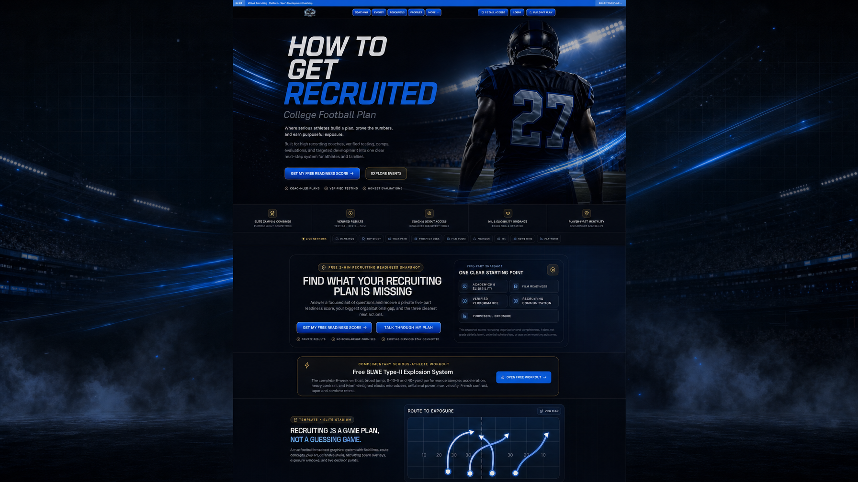
Meta: How to get recruited for college football with academics, film, verified testing, outreach, and purposeful camps.
College football recruiting rewards athletes who treat the process like a job. Talent matters. Organization wins time with coaches who never saw your Friday night lights.
This guide is for high school players and parents who want a realistic path, especially in Michigan and the Midwest, without fake scholarship guarantees.

1. Lock academics early
NCAA Division I initial eligibility requires graduation, a minimum 2.3 core-course GPA, and 16 NCAA-approved core courses. Division II uses a 2.2 core GPA floor. Division III schools set their own admissions rules. Register with the NCAA Eligibility Center and confirm your high school’s approved core list.
NCSA notes profiles with a recent transcript get far more coach views than profiles without one. Keep transcripts current.

2. Build film coaches can use
Lead with 8 to 12 of your best plays. Label position, jersey number, and season. Pair highlights with full-game film. Hudl remains the default for many staffs.

3. Prove numbers with verified testing
Self-reported 40s lose trust. Laser timing, measured jumps, and combine data from reputable events give coaches a shared language.

4. Communicate like a pro
Short email. Height, weight, GPA, position, film link, graduation year, and one sentence on fit. Follow up once. Build a list of 15 to 40 realistic programs.

5. Choose purposeful exposure
Prioritize events and coaches who recruit your level and region. Midwest athletes often win by stacking regional combines with targeted outreach.

30-day checklist
- Eligibility Center account + core-course audit
- Trim and upload current film
- One verified testing date
- One-page athlete profile
- First 10 coach emails sent
Next step: Free BLWE Recruiting Readiness Snapshot at belikewaterexposure.net. Five-part score, biggest gap, three actions. No scholarship promises.

Sources
NCAA Initial Eligibility: www.ncaa.org/eligibility-center/initial-eligibility-requirements/
NCAA Division I: www.ncaa.org/eligibility-center/initial-eligibility-requirements/division-i/
Core courses (NCSA): www.ncsasports.org/ncaa-eligibility-center/ncaa-core-courses
DI fact sheet PDF: fs.ncaa.org/Docs/eligibility_center/Student_Resources/DI_ReqsFactSheet.pdf
NCSA fall checklist: www.ncsasports.org/recruiting/managing-recruiting-process/fall-checklist

2. NCAA Football Eligibility Requirements: What Players Must Track
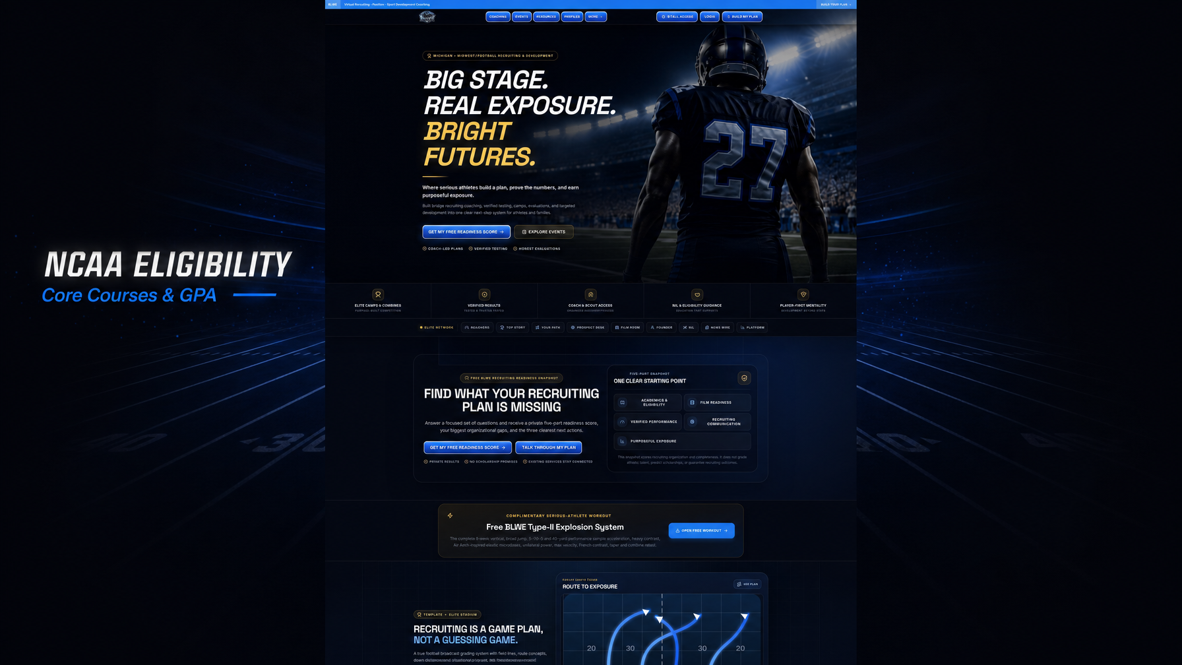
Meta: NCAA football eligibility: core courses, GPA floors, Eligibility Center steps for Michigan high school athletes.
Eligibility mistakes end seasons before the first practice. Families that stay ahead of core courses and GPA avoid panic in senior year.

Division I academic floor
Per NCAA guidance, Division I student-athletes need 16 NCAA-approved core-course credits and a minimum 2.3 core-course GPA. Core GPA only counts approved courses.
Typical DI mix includes 4 years of English, 3 years of math at Algebra I or higher, 2 years of natural or physical science, plus additional cores. Verify against your school’s list on the Eligibility Center site.

Division II and III
Division II requires a minimum 2.2 core-course GPA. Division III does not use the same NCAA core GPA model; admissions rules sit with each school.

Timing rules
NCAA materials stress completing a large share of cores before senior year, including the 10-of-16 benchmark on DI fact sheets. Early graduates still must meet core requirements.

Action steps
- Eligibility Center account in freshman or sophomore year
- Counselor review each semester with the approved list
- Shared folder for report cards and scores
- Flag academic gaps during recruiting reviews
Next step: Free BLWE Recruiting Readiness Snapshot at belikewaterexposure.net. Five-part score, biggest gap, three actions. No scholarship promises.

Sources
NCAA Initial Eligibility: www.ncaa.org/eligibility-center/initial-eligibility-requirements/
NCAA Division I: www.ncaa.org/eligibility-center/initial-eligibility-requirements/division-i/
Core courses (NCSA): www.ncsasports.org/ncaa-eligibility-center/ncaa-core-courses
DI fact sheet PDF: fs.ncaa.org/Docs/eligibility_center/Student_Resources/DI_ReqsFactSheet.pdf
NCSA fall checklist: www.ncsasports.org/recruiting/managing-recruiting-process/fall-checklist

3. How to Get Football Offers: What Actually Moves Coaches
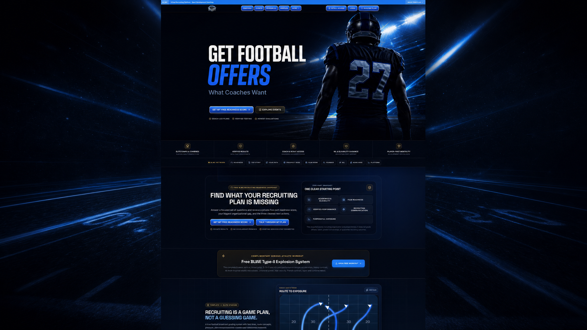
Meta: How to get football offers: what coaches look for and a Midwest playbook for film, testing, and outreach.
Offers follow proof. Coaches need film that shows traits, numbers they trust, grades that clear compliance, and enough contact to know you want their program.

What an offer is
A verbal offer is interest, not a binding contract. Paperwork, academics, and medical clearance still matter. Never shop fake screenshots.

Signals that raise odds
- Consistent starting film against real competition
- Verified speed, explosion, and size for your position
- Clean academic trajectory
- Coachable character notes from high school staff
- Camps where that staff evaluates

Midwest reality
Michigan feeds Big Ten, MAC, FCS, DII, DIII, and NAIA boards every cycle. Many athletes over-index on Power programs and under-work the 20 schools that actually recruit their film.

Weekly routine
Monday film update. Wednesday two coach emails. Friday check replies. Weekend train and log measurables. Monthly one evaluation if budget allows.
Next step: Free BLWE Recruiting Readiness Snapshot at belikewaterexposure.net. Five-part score, biggest gap, three actions. No scholarship promises.

Sources
NCAA Initial Eligibility: www.ncaa.org/eligibility-center/initial-eligibility-requirements/
NCAA Division I: www.ncaa.org/eligibility-center/initial-eligibility-requirements/division-i/
Core courses (NCSA): www.ncsasports.org/ncaa-eligibility-center/ncaa-core-courses
DI fact sheet PDF: fs.ncaa.org/Docs/eligibility_center/Student_Resources/DI_ReqsFactSheet.pdf
NCSA fall checklist: www.ncsasports.org/recruiting/managing-recruiting-process/fall-checklist

4. Michigan High School Football Recruiting: Local Guide
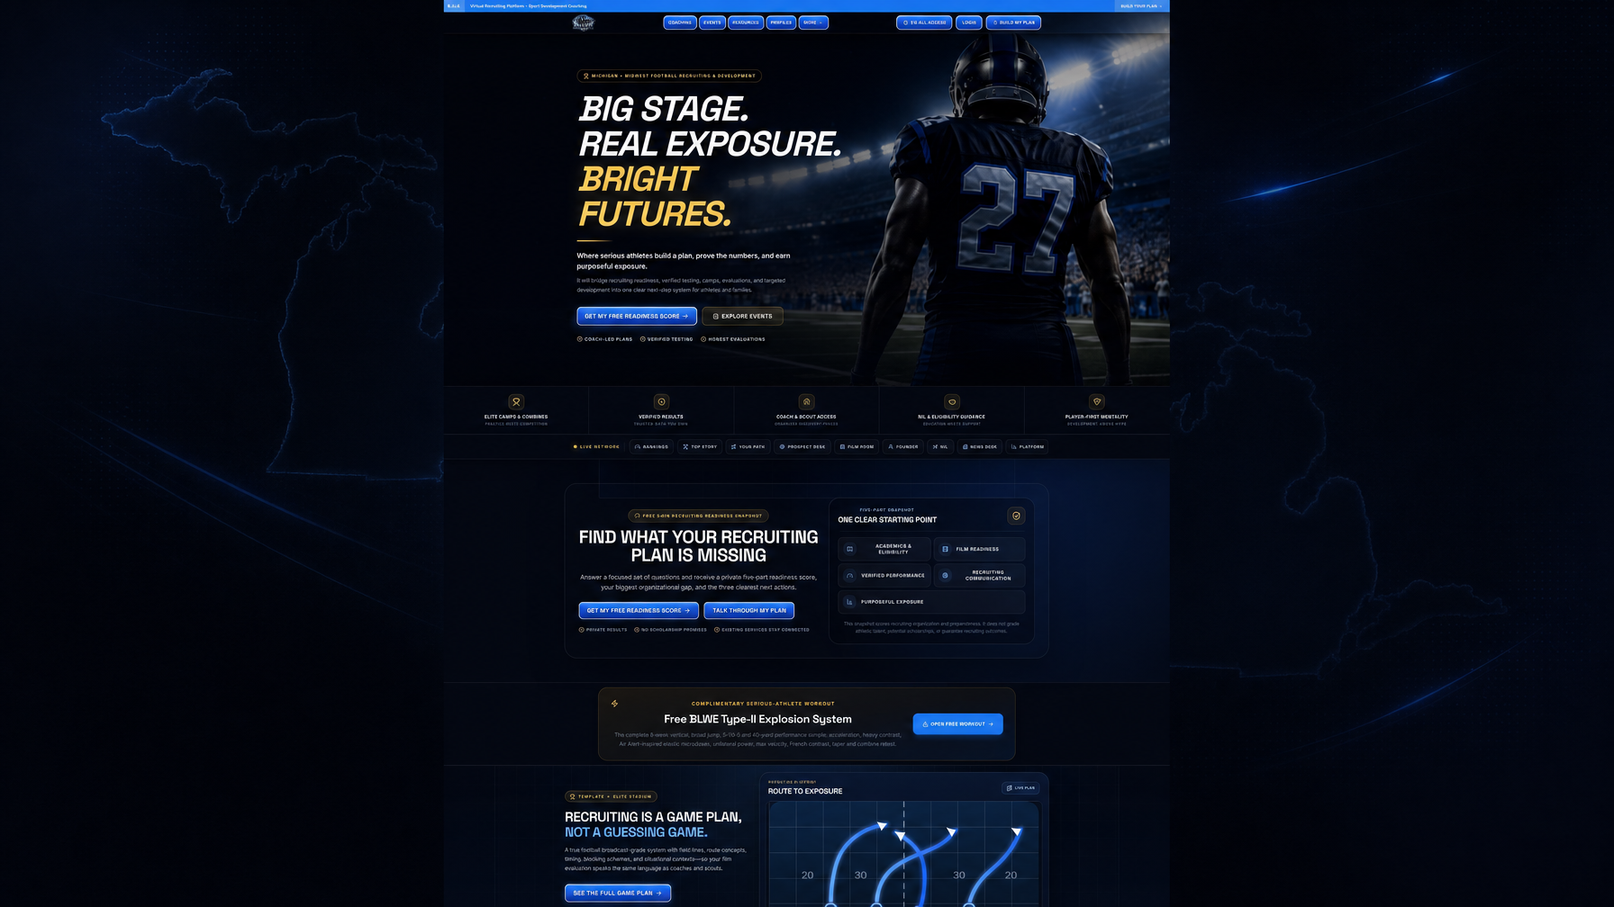
Meta: Michigan high school football recruiting for athletes and parents: local exposure, combines, film, coach outreach.
Michigan produces college talent every year. The gap is rarely effort. It is usually a missing system: film quality, verified data, academic tracking, and coach outreach.

Local structure beats random travel
National events help some players. Many Midwest athletes get more return from regional combines, high school film, and direct emails to staffs that already recruit Michigan.

Your Michigan stack
- In-season film every week
- Off-season verified testing
- Position development plan
- Eligibility Center hygiene
- Target list by division and geography

Parents’ role
Parents manage calendars, transcripts, budgets, and email tone. Athletes own training and film habits. Avoid mass spam with wrong coach names.

Where BLWE sits
Be Like Wat3r Exposure LLC serves Michigan and Midwest athletes with recruiting coaching, verified testing, camps, evaluations, and education-first NIL and eligibility support.
Next step: Free BLWE Recruiting Readiness Snapshot at belikewaterexposure.net. Five-part score, biggest gap, three actions. No scholarship promises.

Sources
NCAA Initial Eligibility: www.ncaa.org/eligibility-center/initial-eligibility-requirements/
NCAA Division I: www.ncaa.org/eligibility-center/initial-eligibility-requirements/division-i/
Core courses (NCSA): www.ncsasports.org/ncaa-eligibility-center/ncaa-core-courses
DI fact sheet PDF: fs.ncaa.org/Docs/eligibility_center/Student_Resources/DI_ReqsFactSheet.pdf
NCSA fall checklist: www.ncsasports.org/recruiting/managing-recruiting-process/fall-checklist

5. Football Combine Michigan: Verified Testing That Helps
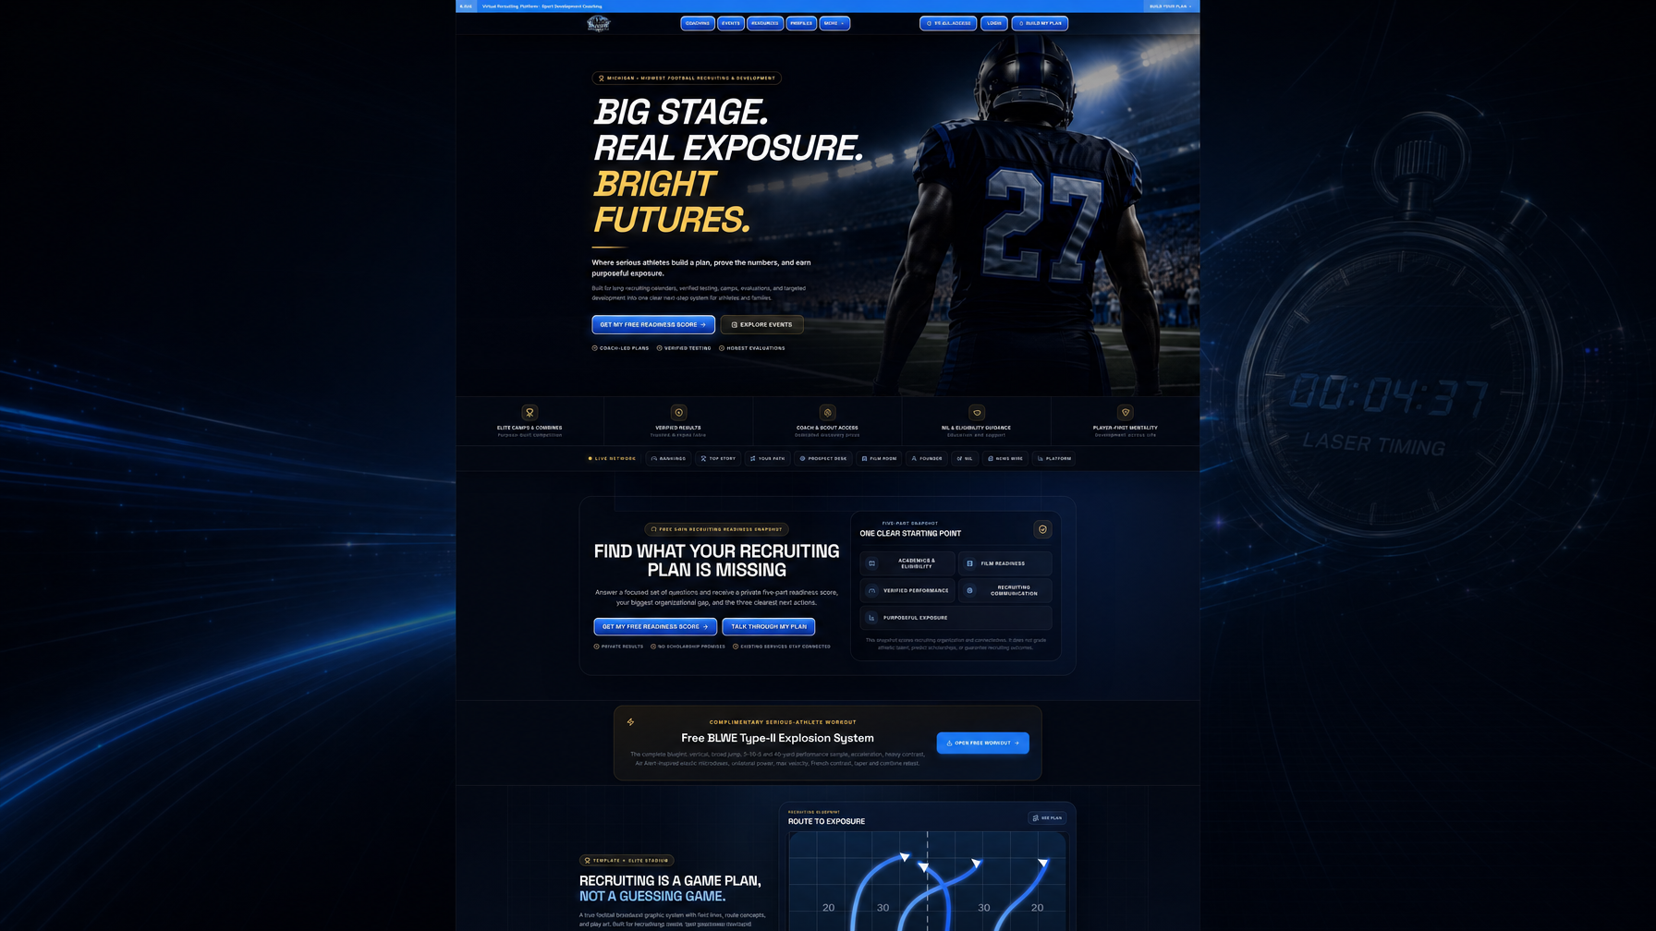
Meta: Football combine Michigan: what gets measured, how to prepare, how verified testing supports recruiting.
A combine is a measurement day, not a magic scholarship machine. Used well, it gives coaches shared numbers and gives you a baseline to beat.

Common tests
Height, weight, wingspan, sprints, shuttle, three-cone, vertical, broad jump, and position drills. Formats vary by event.

Week-before prep
- Sleep and hydration over last-minute PR chasing
- Practice starts and timing commands
- Light speed work, not a heavy squat week
- Listed gear and ID if required

After the combine
Save official results. Update profile and emails within 48 hours. If a number disappoints, schedule a retest plan.

BLWE approach
BLWE builds purpose-built camps and verified results into a wider recruiting plan next to film, academics, and clear actions.
Next step: Free BLWE Recruiting Readiness Snapshot at belikewaterexposure.net. Five-part score, biggest gap, three actions. No scholarship promises.

Sources
NCAA Initial Eligibility: www.ncaa.org/eligibility-center/initial-eligibility-requirements/
NCAA Division I: www.ncaa.org/eligibility-center/initial-eligibility-requirements/division-i/
Core courses (NCSA): www.ncsasports.org/ncaa-eligibility-center/ncaa-core-courses
DI fact sheet PDF: fs.ncaa.org/Docs/eligibility_center/Student_Resources/DI_ReqsFactSheet.pdf
NCSA fall checklist: www.ncsasports.org/recruiting/managing-recruiting-process/fall-checklist

6. Hudl Film for Football Recruiting: What Coaches Want
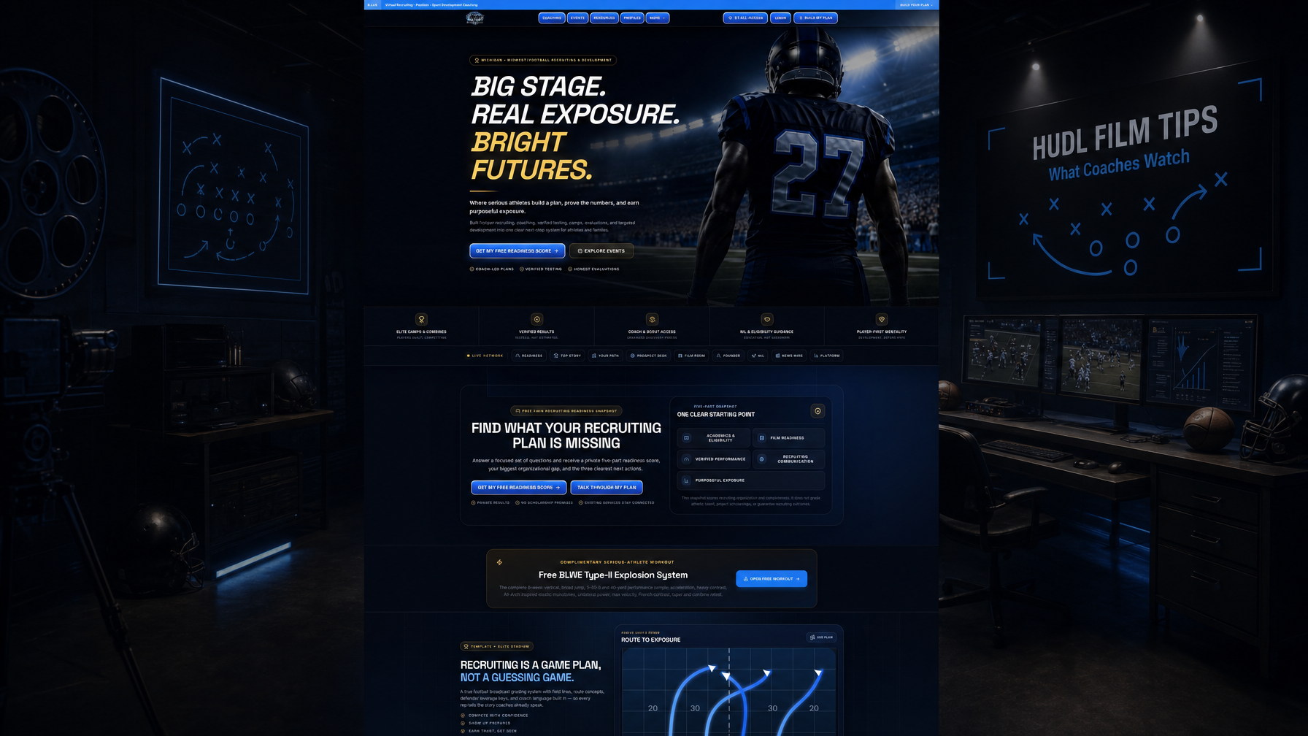
Meta: Hudl film recruiting tips: highlight structure, what coaches watch first, mistakes that get athletes skipped.
Film is still the first filter for most college staffs. Bad packaging can bury good players.

Highlight rules
- Open with your best play
- 8 to 12 plays for a first look
- Show run, pass, pursuit, and space
- Keep jersey number visible
- Title card: name, class, school, position, measurables, contact

Full game film
Coaches who like the teaser will ask for games. Have two or three clean links ready.

Mistakes
Only touchdowns. Weak opponents only. Outdated weight. Broken or private links.

Update cadence
Refresh after every three or four games of meaningful snaps. Tell coaches already in contact when the new link drops.
Next step: Free BLWE Recruiting Readiness Snapshot at belikewaterexposure.net. Five-part score, biggest gap, three actions. No scholarship promises.

Sources
NCAA Initial Eligibility: www.ncaa.org/eligibility-center/initial-eligibility-requirements/
NCAA Division I: www.ncaa.org/eligibility-center/initial-eligibility-requirements/division-i/
Core courses (NCSA): www.ncsasports.org/ncaa-eligibility-center/ncaa-core-courses
DI fact sheet PDF: fs.ncaa.org/Docs/eligibility_center/Student_Resources/DI_ReqsFactSheet.pdf
NCSA fall checklist: www.ncsasports.org/recruiting/managing-recruiting-process/fall-checklist

7. How to Get Noticed by College Football Coaches
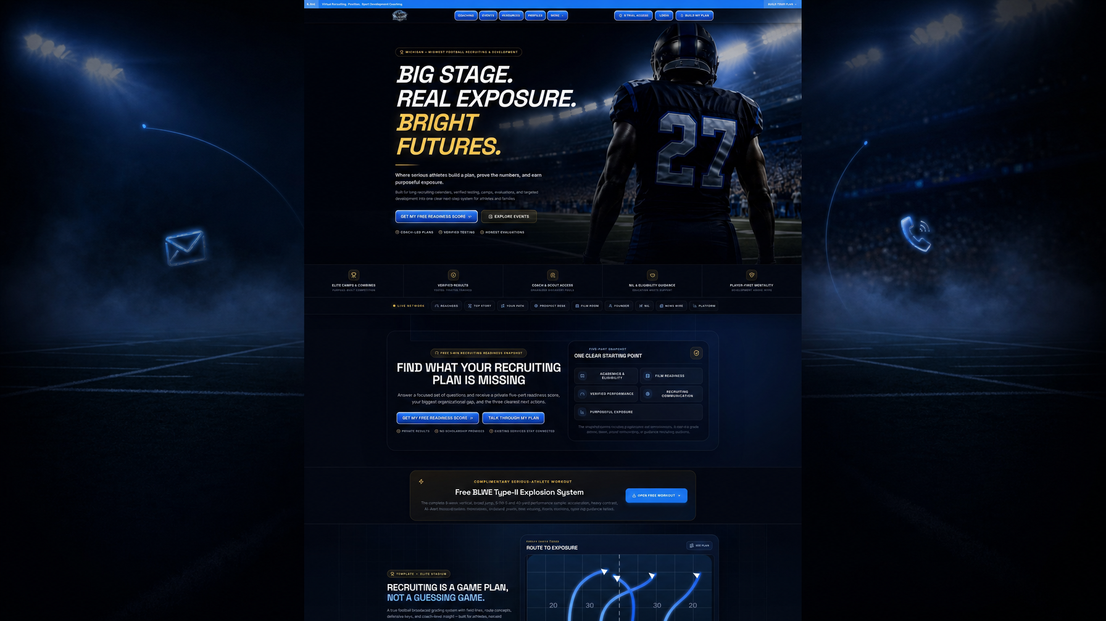
Meta: How to get noticed by college football coaches with camps, email, film, and verified numbers.
Notice comes from repeated, credible signals: film, data, academics, and respectful contact.

Channels that work
- Coach email and staff directories
- Camp evaluations at schools on your board
- High school coach calls to college staffs
- Verified combine result sharing

Email structure
Subject: Class of 202X [Position] [High School] [State]. Body under 120 words: who you are, academics, measurables, film link, why that school, thank you.

What not to do
Daily messages. All-caps. Unverified forties. Mass CC lists. Demanding a scholarship in note one.

Midwest note
MAC, FCS, and regional DII/DIII staffs actively watch Michigan film. Put them on the board early.
Next step: Free BLWE Recruiting Readiness Snapshot at belikewaterexposure.net. Five-part score, biggest gap, three actions. No scholarship promises.

Sources
NCAA Initial Eligibility: www.ncaa.org/eligibility-center/initial-eligibility-requirements/
NCAA Division I: www.ncaa.org/eligibility-center/initial-eligibility-requirements/division-i/
Core courses (NCSA): www.ncsasports.org/ncaa-eligibility-center/ncaa-core-courses
DI fact sheet PDF: fs.ncaa.org/Docs/eligibility_center/Student_Resources/DI_ReqsFactSheet.pdf
NCSA fall checklist: www.ncsasports.org/recruiting/managing-recruiting-process/fall-checklist

8. How to Get D1 Football Offers: A Realistic Path
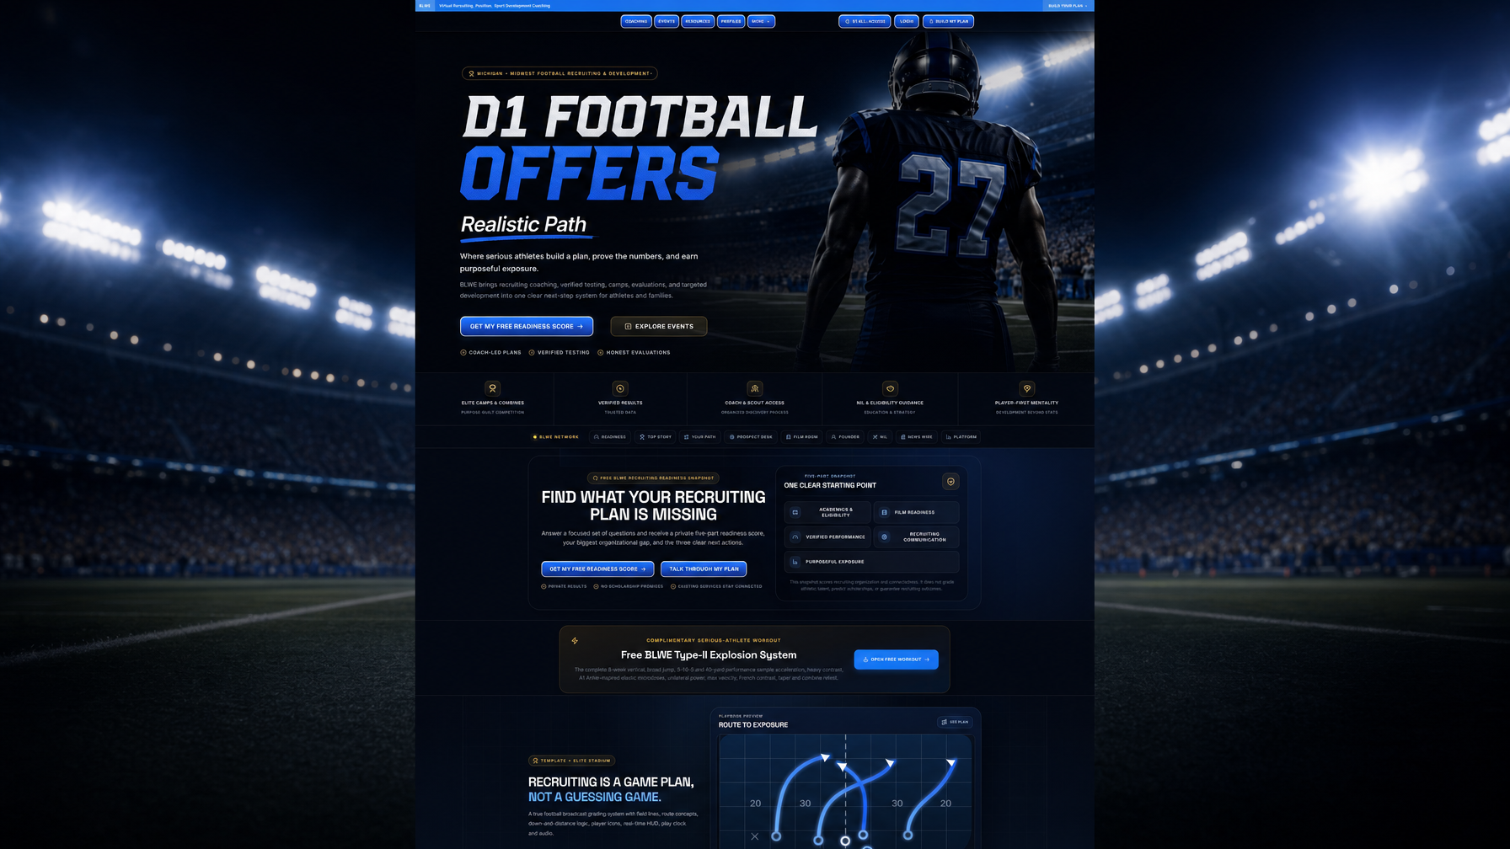
Meta: How to get D1 football offers: realistic standards, academic gates, film bar, step-by-step path.
Division I offers are scarce. Athletes who earn them stack elite traits with clean academics and strong competition film.

The honest bar
Compare yourself to current commits at target schools, not highlight accounts online.

DI eligibility is non-negotiable
Meet NCAA DI core and GPA rules early. A late academic miss can erase athletic interest.

Evidence D1 staffs respect
- Film vs quality opponents
- Verified testing in range for your position
- Camp reps in front of that staff
- Coach recommendations on competitiveness

If D1 is not first
Many players start with FCS, DII, or strong DIII interest and rise. Keep the board wide.
Next step: Free BLWE Recruiting Readiness Snapshot at belikewaterexposure.net. Five-part score, biggest gap, three actions. No scholarship promises.

Sources
NCAA Initial Eligibility: www.ncaa.org/eligibility-center/initial-eligibility-requirements/
NCAA Division I: www.ncaa.org/eligibility-center/initial-eligibility-requirements/division-i/
Core courses (NCSA): www.ncsasports.org/ncaa-eligibility-center/ncaa-core-courses
DI fact sheet PDF: fs.ncaa.org/Docs/eligibility_center/Student_Resources/DI_ReqsFactSheet.pdf
NCSA fall checklist: www.ncsasports.org/recruiting/managing-recruiting-process/fall-checklist

9. Football Recruiting for Parents: Support Without Taking Over
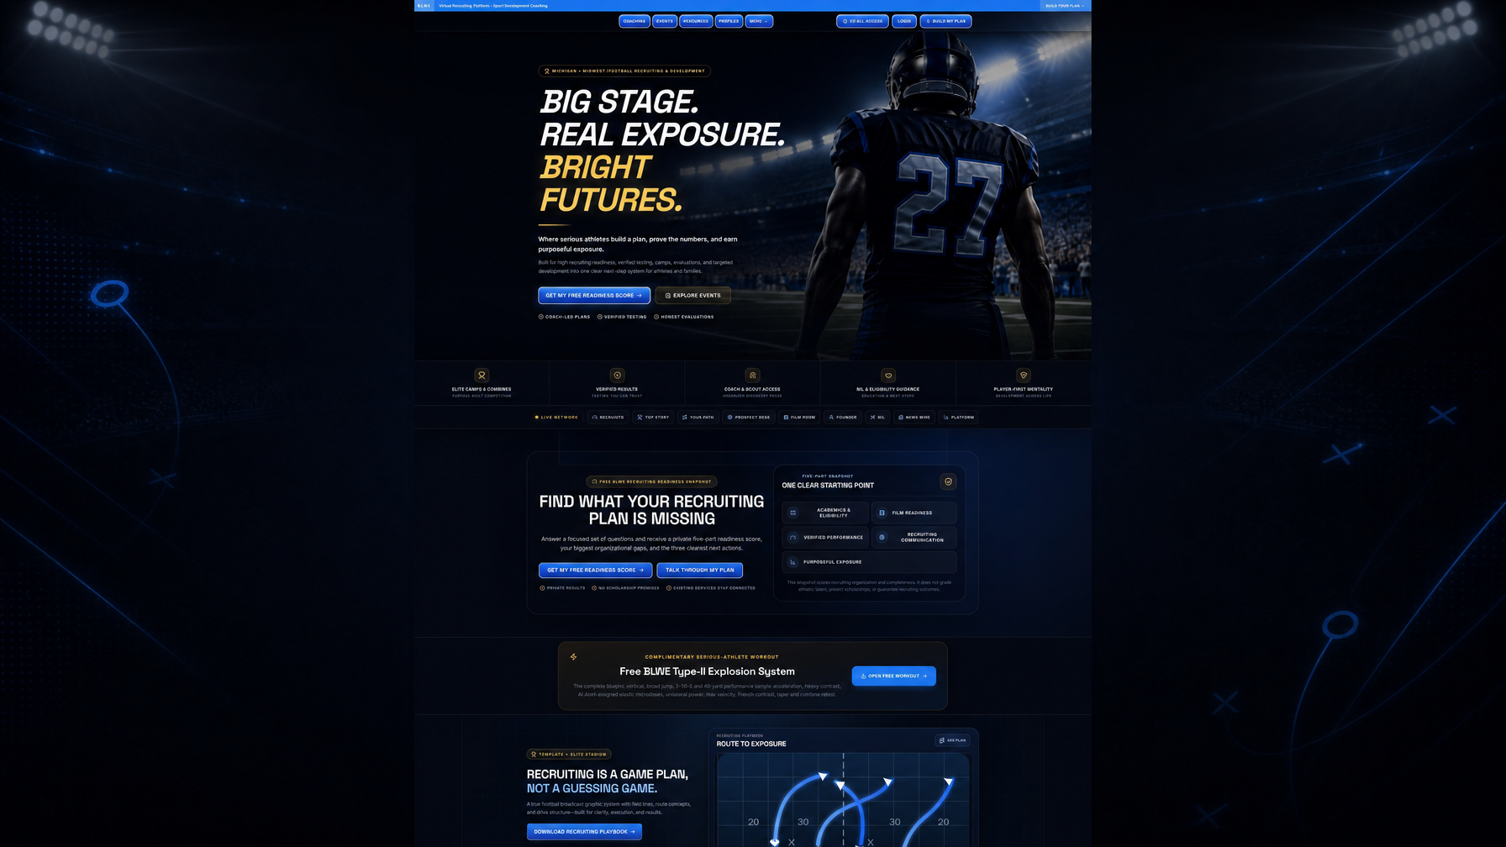
Meta: Parent guide to high school football recruiting: budgets, red flags, academics, healthy support.
Parents fund travel, guard academics, and protect the family from bad actors. Athletes still own the work.

Highest-value jobs
- Transcript and Eligibility Center tracking
- Budget caps before camp season
- Tone check on emails and DMs
- Sleep and mental health in long seasons
- Saying no to events with no verified testing or coach access

Red flags
Guaranteed scholarships for a fee. Pressure contracts. Vague “we send film to every D1” claims. Unclear refunds.

Healthy spend
Prioritize film tools, quality evaluations, training that improves traits, and visits to realistic schools.
Next step: Free BLWE Recruiting Readiness Snapshot at belikewaterexposure.net. Five-part score, biggest gap, three actions. No scholarship promises.

Sources
NCAA Initial Eligibility: www.ncaa.org/eligibility-center/initial-eligibility-requirements/
NCAA Division I: www.ncaa.org/eligibility-center/initial-eligibility-requirements/division-i/
Core courses (NCSA): www.ncsasports.org/ncaa-eligibility-center/ncaa-core-courses
DI fact sheet PDF: fs.ncaa.org/Docs/eligibility_center/Student_Resources/DI_ReqsFactSheet.pdf
NCSA fall checklist: www.ncsasports.org/recruiting/managing-recruiting-process/fall-checklist

10. Midwest Football Showcase Guide: Events That Help
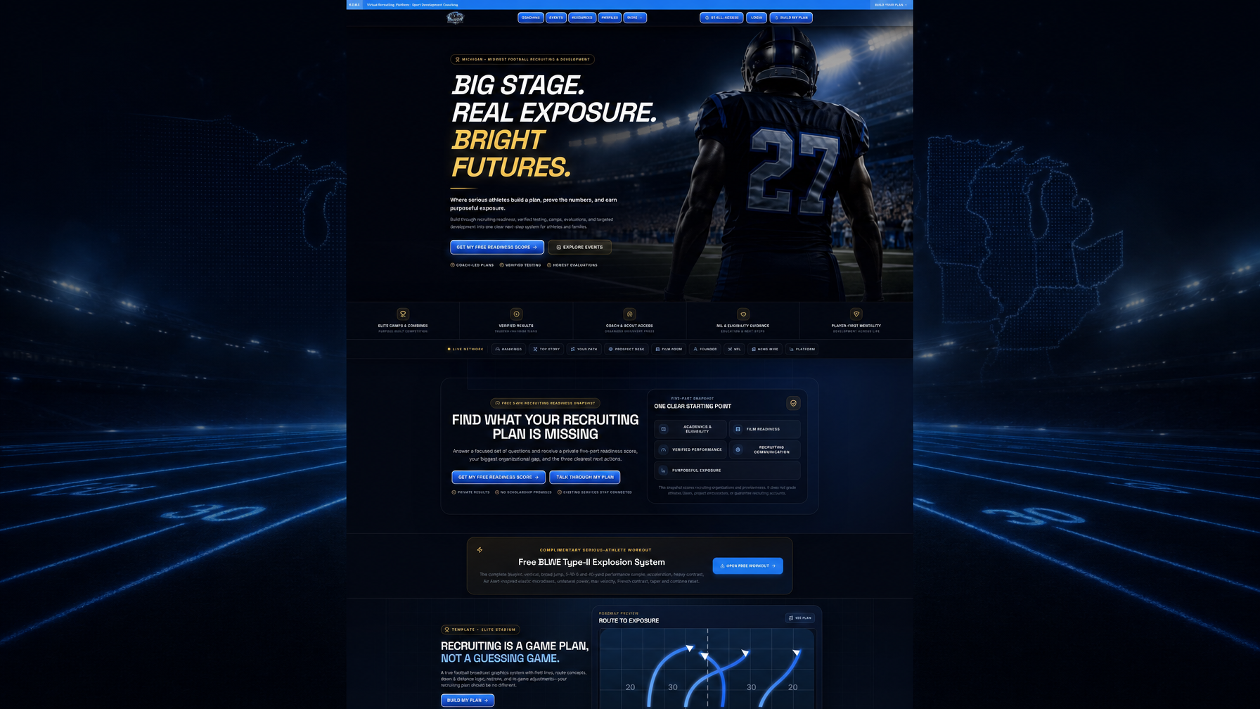
Meta: Midwest football showcase guide: pick events, prepare, turn one day into recruiting follow-up.
Showcases work when they create film, verified numbers, or face time with coaches who recruit your region and level.

Questions before you register
- Which colleges attended last year?
- Are times laser-verified?
- Do you get digital results the same week?
- Is roster size small enough for real reps?
- Cancellation and refund policy?

Day-of
Arrive early. Warm up. Compete every drill. Be coachable. Stay professional.

48-hour follow-up
Update measurables. Send tailored emails. Log results in a simple spreadsheet.

Tie events to a plan
BLWE pairs camps with recruiting coaching so one date becomes part of academics, film, communication, and exposure.
Next step: Free BLWE Recruiting Readiness Snapshot at belikewaterexposure.net. Five-part score, biggest gap, three actions. No scholarship promises.

Sources
NCAA Initial Eligibility: www.ncaa.org/eligibility-center/initial-eligibility-requirements/
NCAA Division I: www.ncaa.org/eligibility-center/initial-eligibility-requirements/division-i/
Core courses (NCSA): www.ncsasports.org/ncaa-eligibility-center/ncaa-core-courses
DI fact sheet PDF: fs.ncaa.org/Docs/eligibility_center/Student_Resources/DI_ReqsFactSheet.pdf
NCSA fall checklist: www.ncsasports.org/recruiting/managing-recruiting-process/fall-checklist

